|  |  |
| --- | --- |
| **DOKUMENTASI EKSTERNAL**  External Documentation |  |
| **[TUGAS PROYEK]**  **[*Assignment / Project*]** |
| **MATAKULIAH <B901> – <Human computer >**  ***Subject*** |
| SEMESTER [GENAP] 2019/2020 ***[Odd/Even/Compact] Semester Year 20199/2020*** |

## Judul Proyek

*[Assignment / Project]**Title*

* **Miku E-skpo**

## Pendahuluan

*Introduction*

* **INTRODUCTION**

miku E-skpo acara yang menyediakan berbagai acara dan penjualan tiket untuk konser miku E-skpo pembelian bisa melalui website ini dan website ini menyediakan informasi schedule yang akan dijalankan sehingga pembeli tau acara apa saja yang akan disedia kan oleh kami

## Dokumentasi

*Report / Documentation*

* **REPORT / PRINT SCREEN & DESCRIPTION**

**Logo**

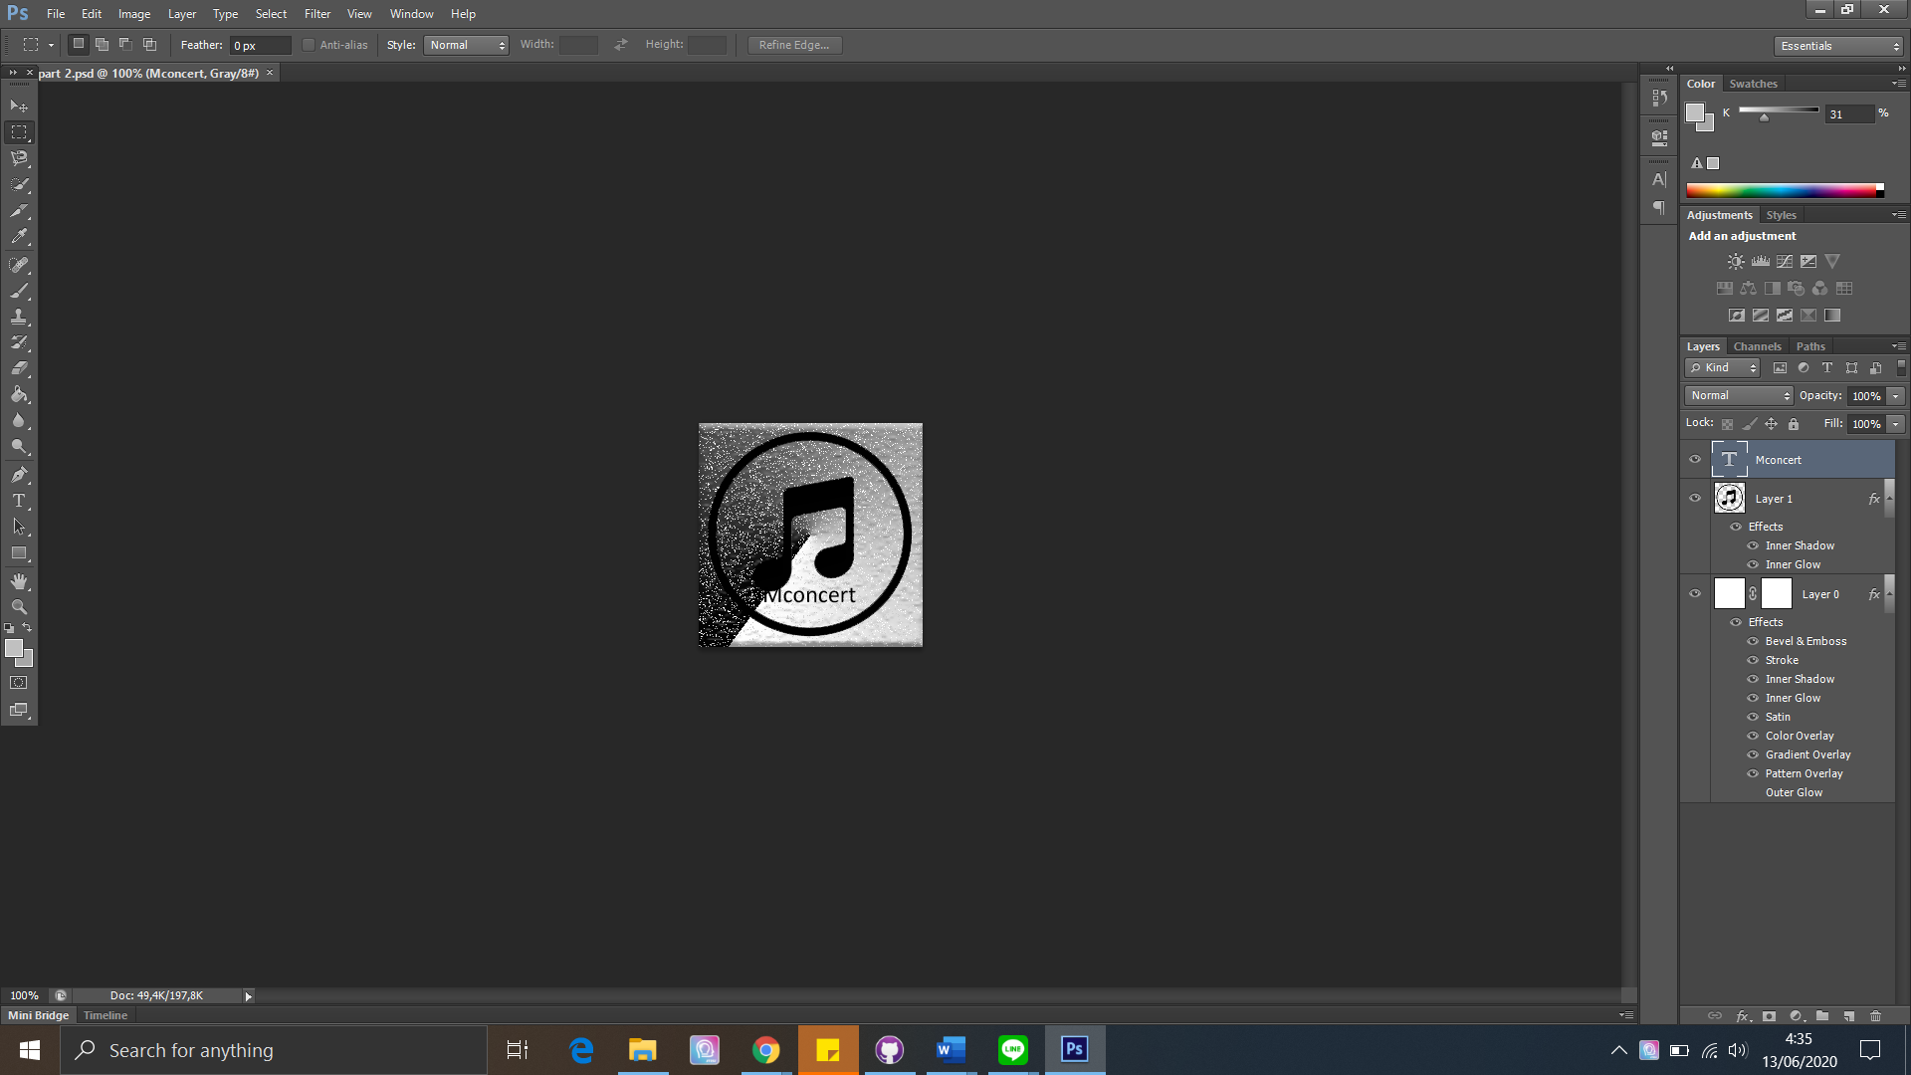

* + - Logo with text “Mconcert” and tone icon. We make tone icon with 2 effects, and that logo we add 8 effects

**Photoshop**

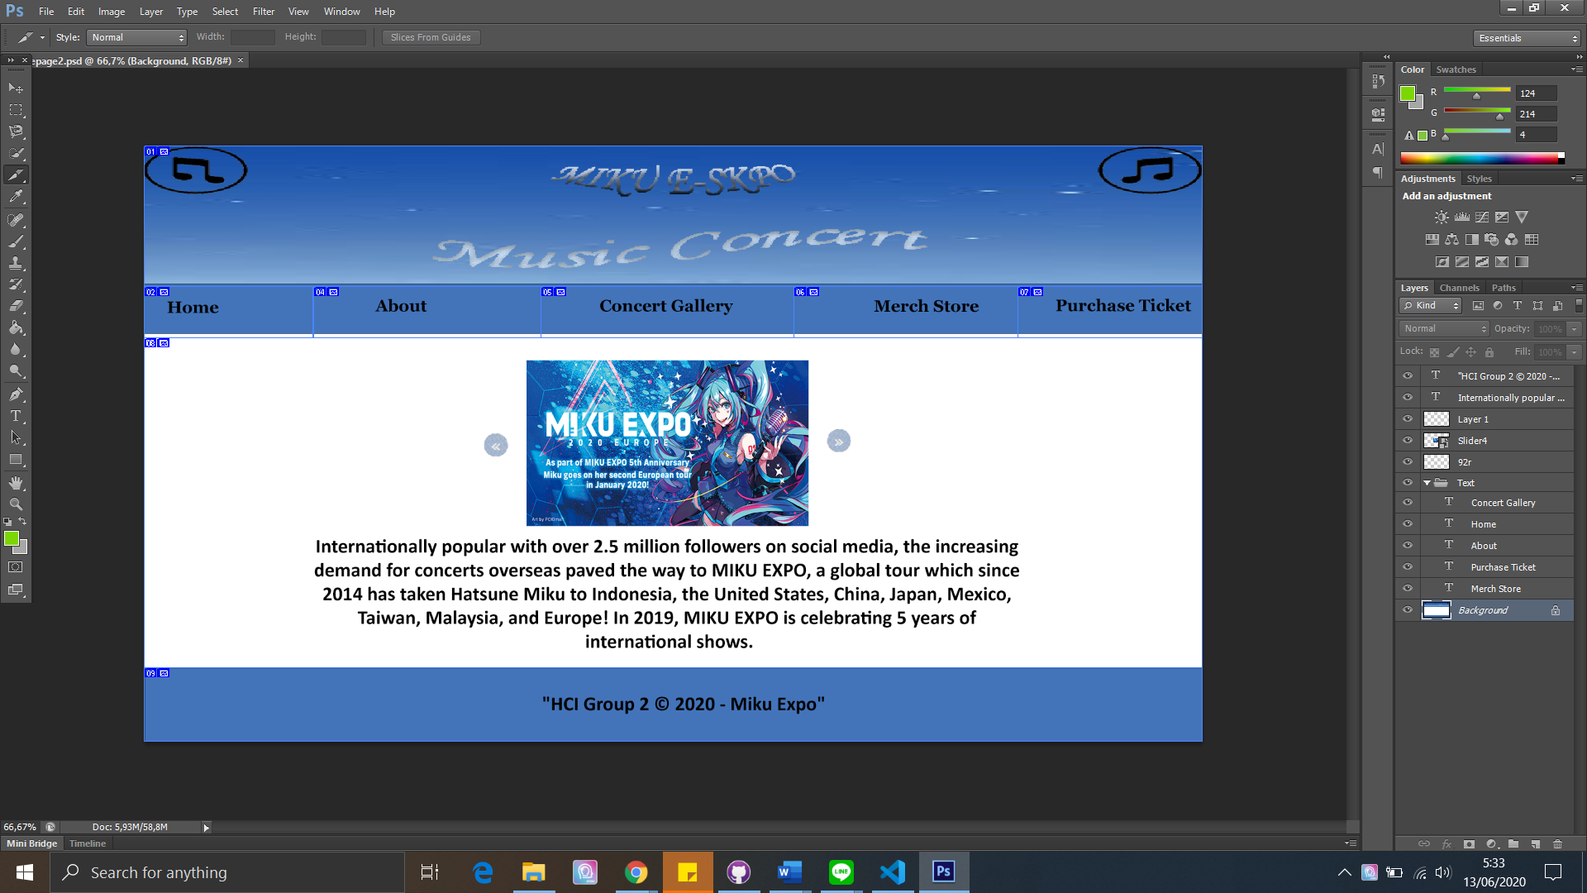

* + - Template for home page, contain about header, nav bar, content, footer
    - Header for title, nav bar for navigation, footer about copyright, and content about image slider, and information about Hatsune Miku
    - And slice it, so the website will be ready for export to web

**WEB**

* + **Home**

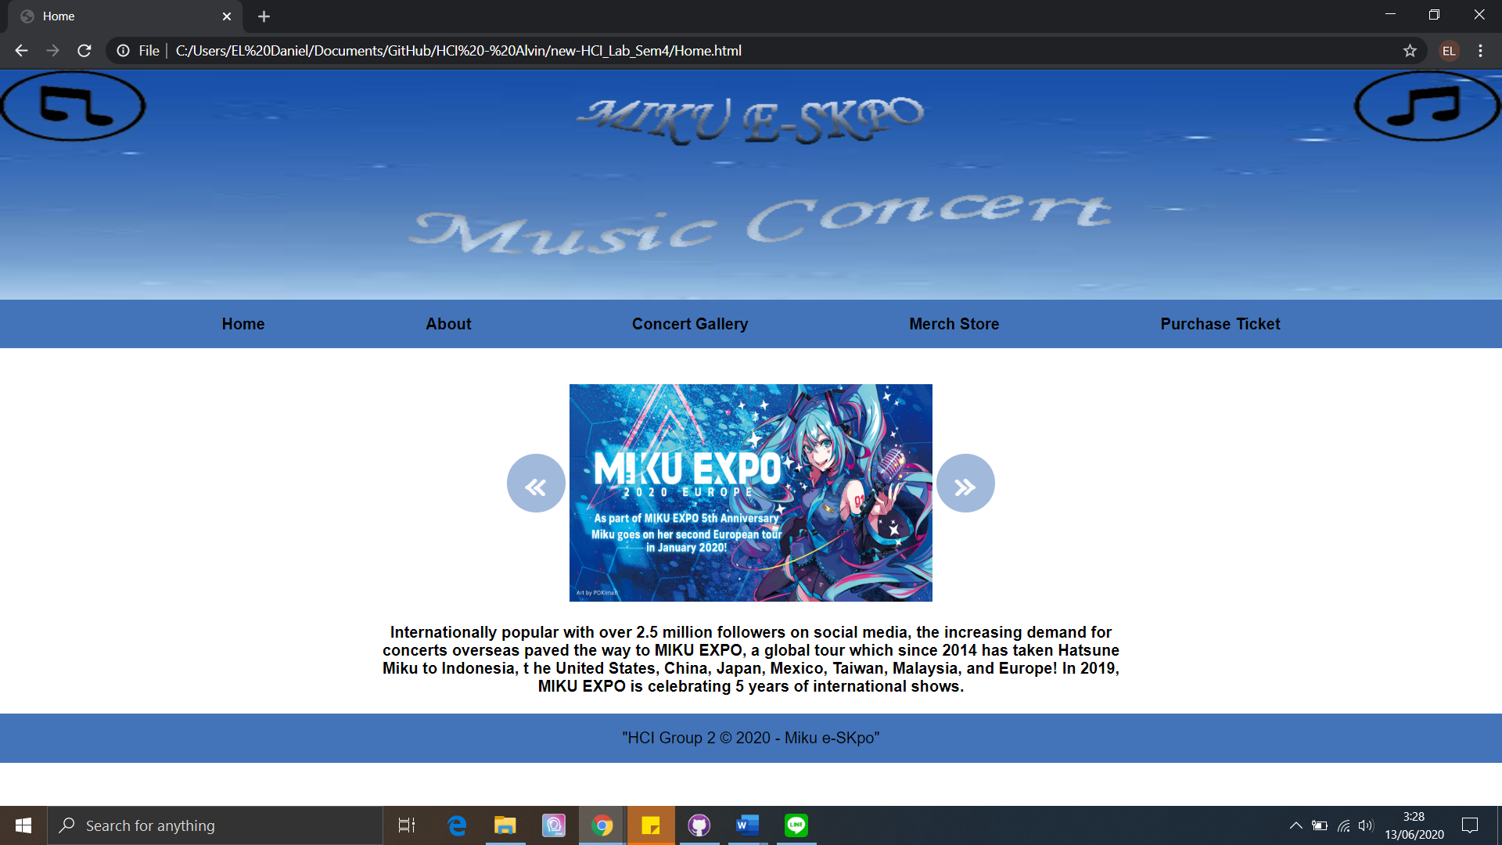

* + - Header contains logo, design, and main color scheme
    - Nav bar, navigation contain button for change to another page (Home, About, Concert Gallery, Merch Store, Purchase Ticket). There is drop down menu in About contain About Us and Line Up Concert
    - Content About information Miku Expo and there is image slider
    - Image sliders have 3 images, image from last expo, vocaloid all-star, and promo for merchandise
  + **About Us**

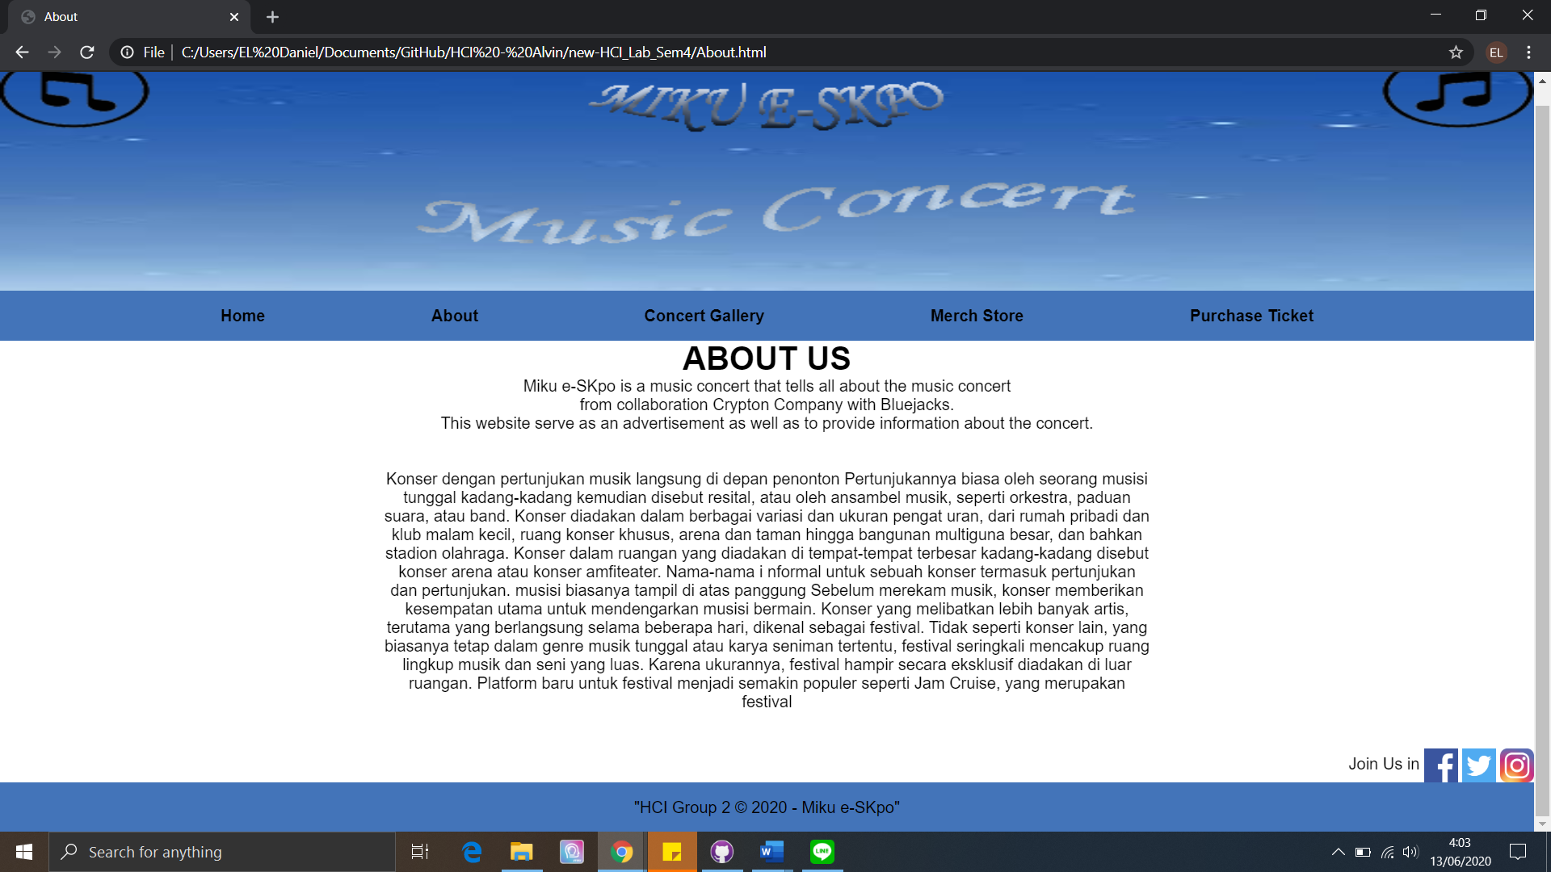

* + - This page provides information about the event, and there is specific information about expo
    - In bottom right there are 3 button to open Hatsune miku official social media (facebook, twitter, instagram)
  + **Line Up Concert**

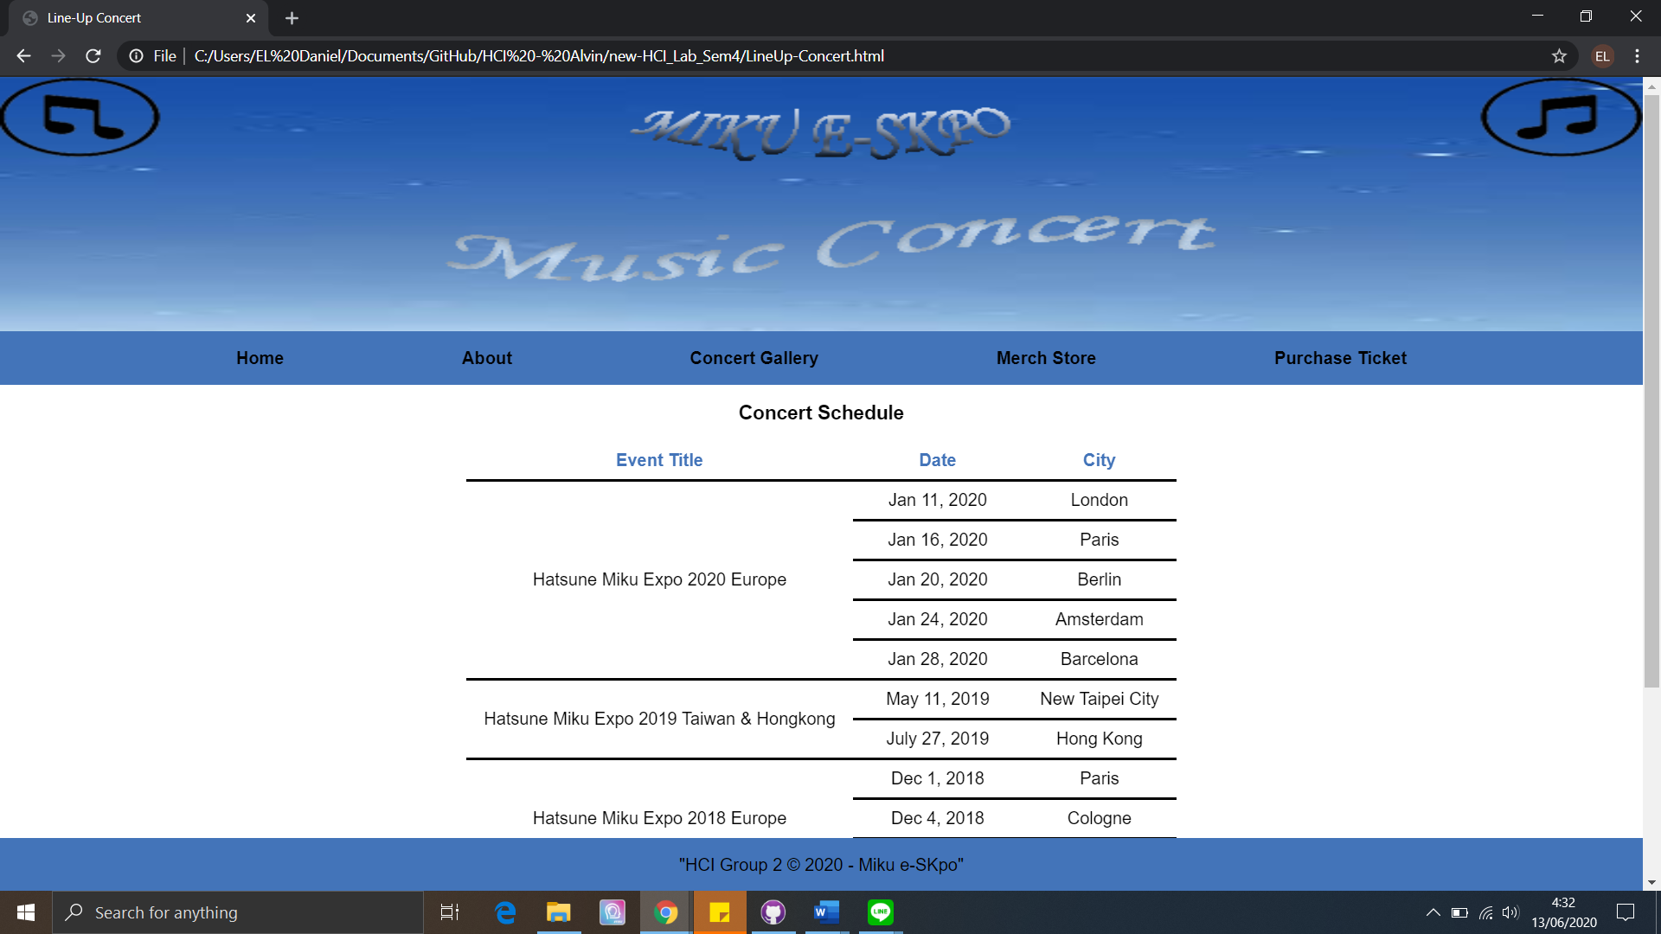

* + - Contain about Hatsune Miku information about previous expo, title, date, and city
  + **Concert Gallery**

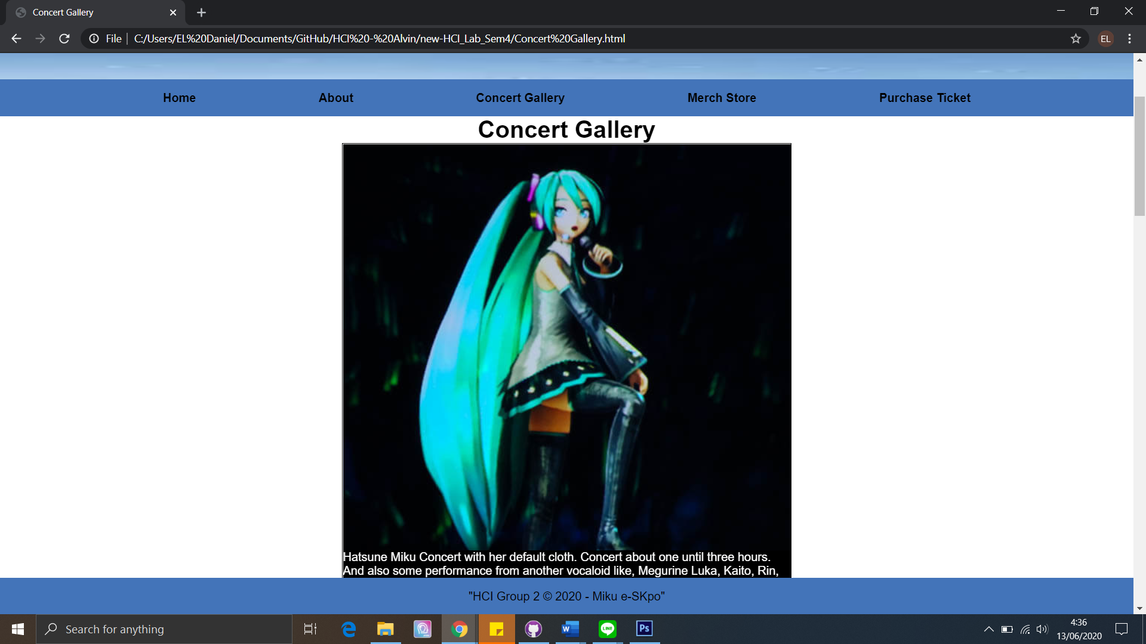

* + - Contain about gallery in previous event, and some explanation about gallery
  + **Merch Store**

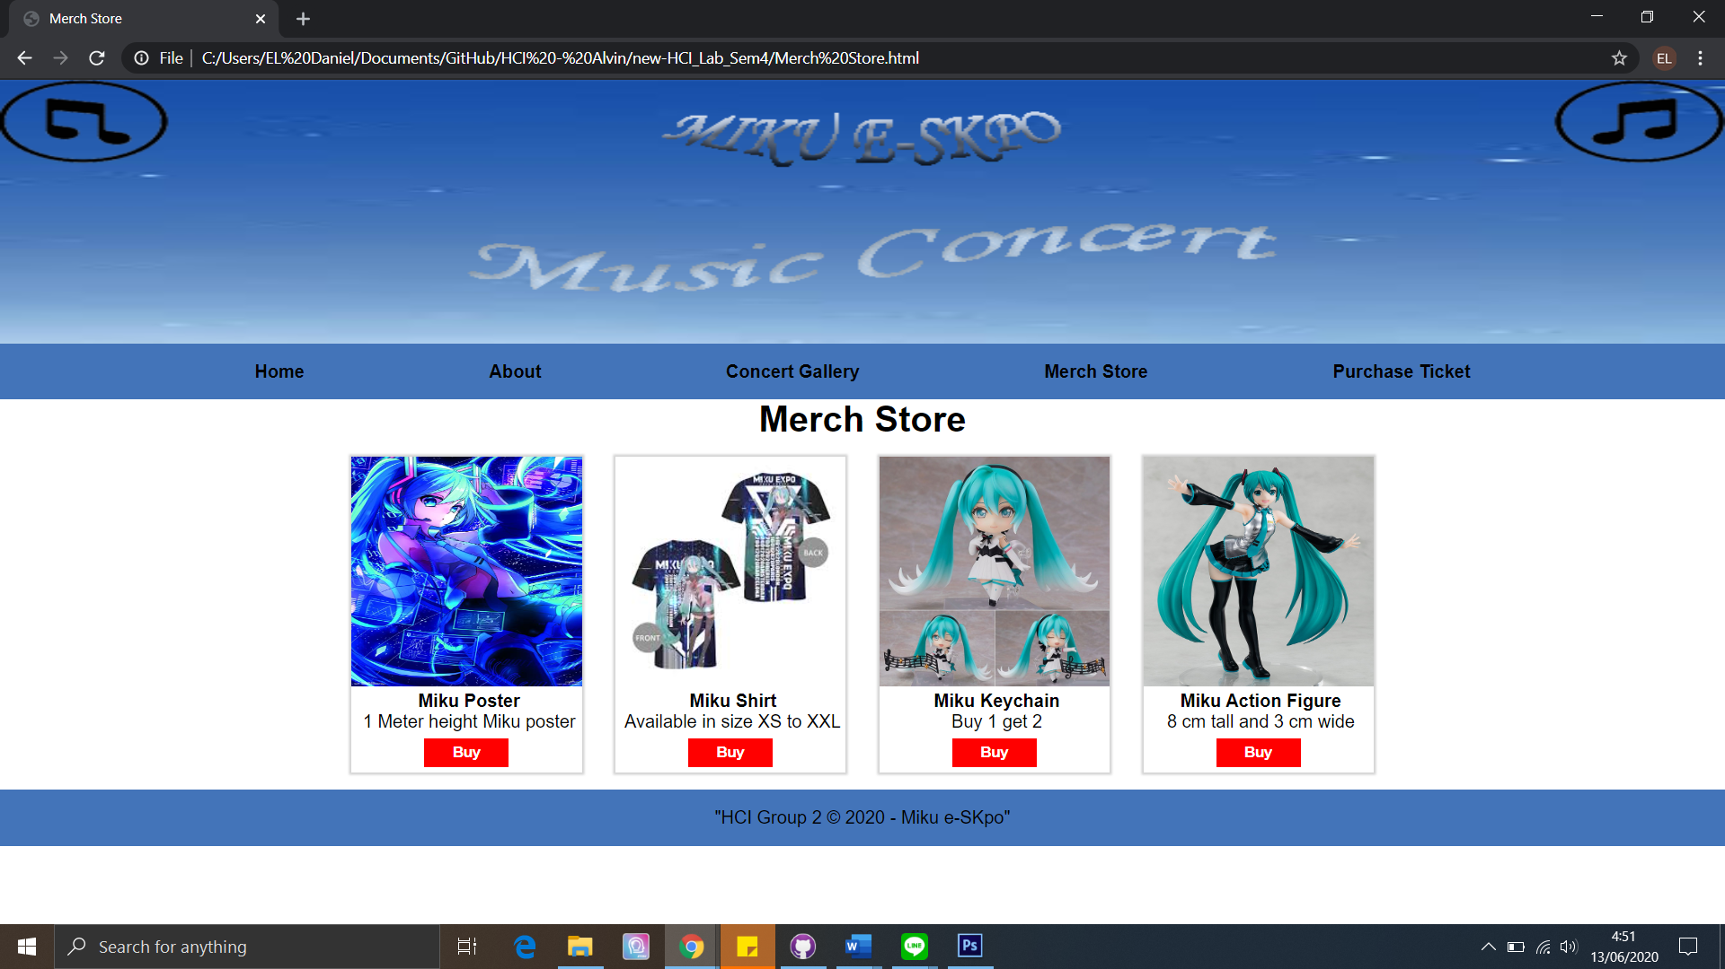

* + - Page for buy official merchandise like poster, shirt, keychain, action figure, etc. There is photo, description and buy button
  + **Purchase Ticket**

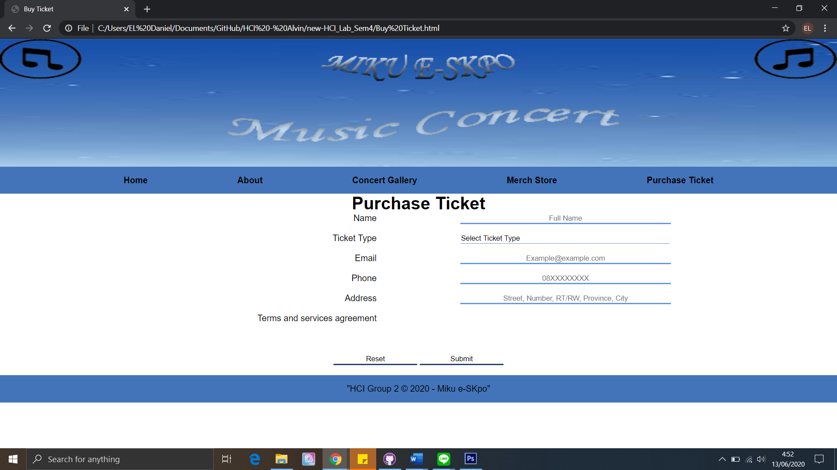

* + - Page for customer to buy ticket for next event
    - If you some error happen, JQuery will show error in windows alert
    - If you have succeeded, JQuery will show data that customer already input by customer

## Referensi

*References*

* **REFERENCES**

Google image

Miku expo website

* **LINK**

<https://www.google.co.id/imghp?hl=id&tab=wi&authuser=0&ogbl>

<https://mikuexpo.com/>

Disiapkan Oleh,

*Prepared by,*

* **<2201732790> - < kennykey>**
* **<2201810395> - < Daniel>**
* **<2201815194> - <Alvin>**